DATABASE Design

- Customer
Customer
ID
Name
Address
Contact
Gender
Age

- Plans

Plan
ID
Plans Name
Duration
Amount
Calls
SMS
Data

- Orders

Order
Cust-ID
Plans-ID
ID
Bill

- Offers

Offer
ID
Name
Duration
Description

- Queries

Query
Customer-ID
Plan-ID
ID
created-Date
Description

Architecture diagram

VoizFonica

Resgistration
Recharge
Pay bill
Buy new connection
View plans
Pay bill
Buy new connection
Switch prepaid-postpaid

Recharge
New connection
View plans
Switch prepaid-postpaid

ge

Contact us
Online support
Login
Help
Dongle
Post-paid
Prepaid

UM

UML Diagram
- Class Diagram

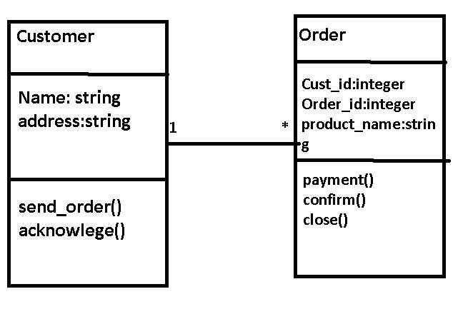
Recharge
Customer
1 1
Cust_id:integer
Name:string
Id:integer
Plan:string
Amount:double
Select_plan()
Payment()
Acknowledge()

Confirm()

- Use-case Diagram

Authentication
Login

Browse plans
<<include>>
Payment gateway
Pay bill
customer

Help

Admin
Update plans
Customer support

